Tanishka Art Gallery

INTRODUCTION TO PROJECT

Website is one of the sources, where people can get information related to any subject. As there is no such more website of “.Home Foods”, so to introduce about the field and its features to all people, the website is designed. Publishing customer‟s information with good representation over the web is the main objective. Project aim is to design a website on “Tanishka Art Gallery” -provides full detailed information about Tanishka Art Gallery.

The World Wide Web (WWW or web) can be considered as a large distributed information system that provides access to shared objects. It is currently one of the most popular applications running on the Internet and its usage is expected to grow further in future. We also develop a website which is Tanishka Art Gallery. Our website provides arts on order of home delivery .To develop our website we use HTML.

Jaysingpur College, Jaysingpur Page 1

Tanishka Art Gallery

TECHNOLOGY

A)HTML

HTML is a hyper text markup language. The word markup was used by editors who marked up manuscripts (usually with a blue pencil) when giving instructions for revisions. "Markup" now means something slightly different: a language with specific syntax that instructs a Web browser how to display a page.

Once again, HTML separates "content" (words, images, audio, video, and so on) from "presentation" (instructions for displaying each type of content). HTML uses a pre-defined set of elements to define content types. Elements contain one or more "tags" that contain or express content. Tags are enclosed by angle brackets, and the closing tag begins with a forward slash.

Tim Berners-Lee, physicist at CERN (the European Organization for Nuclear Research), devised a way in the late 1980s for scientists to share documents over the Internet. Before that, Internet communication had been limited to plain text, using technologies such as email, FTP (File Transfer Protocol), and Usenet-based discussion boards. HTML used a content model stored on a central server but transferrable to a local workstation and viewable in a browser, simplifying access to content and making "rich" content possible (such as sophisticated text formatting and images). HTML is derived from SGML, which is a complex syntax for marking up or binding of content (text or graphics) in documents; as of HTML5, HTML no longer attempts to adhere to SGML syntax.

B)JavaScript

JavaScript only execute on the page(s) that are on your browser window at any set time. When the user stops viewing that page, any scripts that were running on it are immediately stopped. The only exceptions are cookies or various client side storage APIs, which can be used by many pages to store and pass information between them, even after the pages have been closed.

JavaScript is a programming language that can be included on web pages to make them more interactive. You can use it to check or modify the contents of forms, change

Jaysingpur College, Jaysingpur Page 2

Tanishka Art Gallery

images, open new windows and write dynamic page content. You can even use it with CSS to make DHTML (Dynamic Hyper Text Markup Language).

JavaScript is a client side, interpreted, object oriented, high level scripting language, while Java is a client side, compiled, object oriented high level language. Now after that mouthful, here's what it

C) CSS

CSS stands for Cascading Style Sheets.CSS describes how HTML elements are to be displayed on screen, paper or in to other media.CSS saves a lot of work. It can control the layout of multiple web pages all at ones. External style sheets are stored in CSS files.CSS is a style sheet used to define styles for your web pages.

The most common way to add styling is to keep the style in separate CSS files.CSS is a style sheet language used for describing the presentation of the document written in markup language. CSS describes how elements must be rendered on screen, on paper, on in other media. The style defines are normally saved in external.css files.

Jaysingpur College, Jaysingpur Page 3

Tanishka Art Gallery

EXISTING SYSTEM

Virtualy any medium can be used for advertising. An old website in the information is not sufficient to user. The record of the daily routing registered in the manual form. But it is the very time consuming process. Information in the register is presented not for large amount.

To prepare the menus of arts which is used in the conducting will take more time, currently it is doing as a one day process for verifying all records. So after conducting the feasibility study we decided to make the manual Tanishka Art Gallery to be computerized. Any place an "identified" pays to deliver their message through a medium is advertising. Virtually any medium can be used for advertising whole people used in internet.

.Disadvantages of Existing System-

- Lack of communication between buyer & seller.

- Manual search for product in store or anywhere.

- Fail in tracking of product.

- Current system is very time consuming

Jaysingpur College, Jaysingpur Page 4

Tanishka Art Gallery

NEED AND SCOPE

Need of the website:

In previous days the people use to go to near by Tanishka Art Gallery and get information about the Tanishka Art Gallery

This website is published mainly keeping in mind of user. When users access this website he

will find all information about Art Gallery and its updates. Another main aim of this project

is to save the time of the people because in modern day world they don‟t have time to go to

nearby Art Gallery and gather information about the Art Gallery. We provide all information

about features, services etc

1. Online brochure:

Companies spent millions creating brochures & distributing them. By having a website you can skip that entirely.

2. More customers:

More than 2.4 billion people use the internet every day, and some 90% of those have purchased something. So you can get more customer.

3. Marketing:

The internet has opened up a whole world of marketing that didn‟t exit before.

Scope of the website:

At Art Gallery, we dream big. Our future plans, therefore, cover almost every area of our existence.

The other areas of future focus are our product range and geographical reach. We have concrete plans of bringing in various new products into the market in near future. In addition, we are expanding our network and exploring new geographical areas.

Jaysingpur College, Jaysingpur Page 5

Tanishka Art Gallery

PROPOSED SYSTEM

The Proposed system is web based application. The computerized system records all information. This system is used by internet. All information is given through proposed system. In this project the user can gives the feedback to the system. Our system gets the information about various arts which is used in conducting people.

Advantages of Proposed system-

- User can choose best option for get knowledge.

- The user can give the feedback to the system.

- The information is available to be accessed by anyone, anywhere, anytime.

- The information within a site can be quickly accessed.

- The site can be updated to always provide the latest information

Limitations of Proposed System-

1. Viewing problem -

When technical issues occur system loss the opportunity to broadcast

advertisements for their services .

- Do not cover all the types that should be present for Art gallery

- Threat to security level.

Jaysingpur College, Jaysingpur Page 6

Tanishka Art Gallery

REQUIREMENT GATHERING

Waterfall Model design:

Waterfall approach was first SDLC Model to be used widely in Software Engineering to ensure success of the project. In "The Waterfall" approach, the whole process of software development is divided into separate phases. In Waterfall model, typically, the outcome of one phase acts as the input for the next phase sequentially.
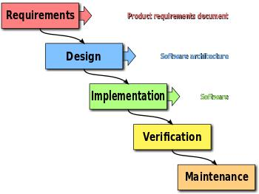

Jaysingpur College, Jaysingpur Page 7

Tanishka Art Gallery

The sequential phases in Waterfall model are:

  - Requirement Gathering and analysis: All possible requirements of the system to be developed are captured in this phase and documented in a requirement specification doc.

  - System Design: The requirement specifications from first phase are studied in this phase and system design is prepared. System Design helps in specifying hardware and system requirements and also helps in defining overall system architecture.

  - Implementation: With inputs from system design, the system is first developed in small programs called units, which are integrated in the next phase. Each unit is developed and tested for its functionality which is referred to as Unit Testing.

  - Integration and Testing: All the units developed in the implementation phase are integrated into a system after testing of each unit. Post integration the entire system is tested for any faults and failures.

  - Deployment of system: Once the functional and non-functional testing is done, the product is deployed in the customer environment or released into the market.

- Maintenance: There are some issues which come up in the client environment. To fix those issues patches are released. Also to enhance the product some better versions are released. Maintenance is done to deliver these changes in the customer environment.

Jaysingpur College, Jaysingpur Page 8

 |  |  |  | Tanishka Art Gallery
 |  | SYSTEM ANALYSIS
 |  | SITE–MAP
 |  |  | SITEMAP
HOME | Choose | Gallery | Contact | About | Feedback
HOME |  | Gallery | bout us
 | by type |  | us | us | form
Jaysingpur College, Jaysingpur |  |  |  |  | Page 9

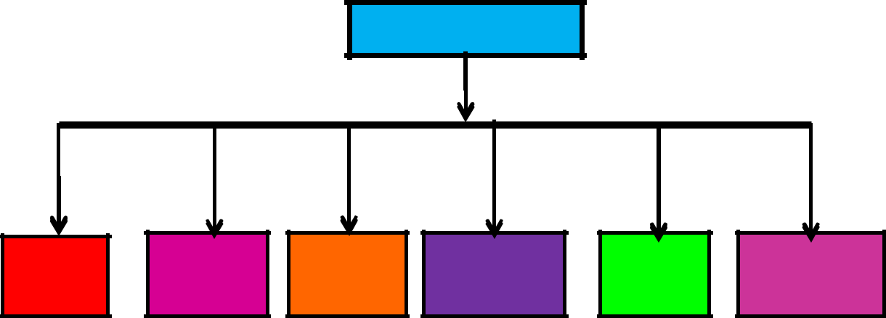
Tanishka Art Gallery

SYSTEM DESIGN

Database Design:-

Feedback:

Field Name | Data Type | Constraints | Description
USERNAME | Text | Primary Key | Name of the user
ADDRESS | VARCHAR | Not Null | Name of the state
CONTACT | NUMBER | Unique | Contact of the user
EMAIL ID | VARCHAR | Check | Email id of the user
DESCRIBE | Text | Not Null | Good,very good,bad
Order Form:-
Field Name | Data Type | Constraints | Description
USERNAME | Text | Primary Key | Name of the user
EMAIL ID | VARCHAR | Check | Email id of the user
PASSWORD | NUMBER | Unique | Password of the user
CONTACT NO | NUMBER | Check | Contact of the user
CURRENT | Text | Not Null | Current address of user
ADDRESS
PAINTING TYPE | Text | Not Null | Name of the painting
PRICE | NUMBER | Unique | Price of the painting

Input design:-

Home page:

<html lang="en">

<head>

<meta charset="UTF-8">

<title>HOME</title>

<style>

Jaysingpur College, Jaysingpur Page 10

Tanishka Art Gallery

body{ padding: 0;

margin: 0;

}

.vid-container{

position: relative;

height: 100vh;

overflow: hidden;

}

.bgvid{

position: absolute;

left: 0;

top: 0;

width: 100vw;

}

.inner-container{

width: 400px;

height: 470px;

position: center;

top: calc(44vh-200px);

left: calc(50vw-200px);

overflow: hidden;

}

.mark{

position: absolute;

height: 100%;

width: 100%;

font-family:tahoma;

Jaysingpur College, Jaysingpur Page 11

Tanishka Art Gallery

color: aqua;

background: rgba(0,0,0,0.13);

padding: 30px 0px;

}

h1{

color:black;

margin-left:30%;

}

h1 a:hover{

text-decoration:none;

color: white;

padding:5px 20 px;

}

h1 A:hover{

text-decoration:none;

color: pink;

padding:5px 20 px;

}

a:hover

{color:red;

}

a{

text-decoration:none;

padding:20px;

}

</style>

</head>

Jaysingpur College, Jaysingpur Page 12

Tanishka Art Gallery

<body>

<div class="vid-container">

<div class="inner-container">

<video src ="color.mp4"

class="bgvid inner" autoplay muted loop>

</video>

<div class="mark">

<h2 style="background-color:transparent">

<center>

<a href="index.html" target="home">Home</a>

|

<a href="pro.html" target="home">Choose by type</a>

|

<a href="flip.html" target="home">Gallery</a>

|

<a href="contactus.html" target="home">Contact us</a>

|

<a href="aboutus.html" target="home">About us</a>

|

<a href="feedback.html" target="home">Feedback</a> </<div></h2> <br />

</center>

<marquee direction="left ">

<img src="4.jpg" height="250" width="300">

<img src="5.jpg" height="250" width="300">

<img src="6.jpg" height="250" width="300">

<img src="7.jpg" height="250" width="300">

Jaysingpur College, Jaysingpur Page 13

Tanishka Art Gallery

<img src="8.jpg" height="250" width="300"> <img src="9.jpg" height="250" width="300"> <img src="10.jpg" height="250" width="300"> <img src="11.jpg" height="250" width="300"> </marquee> <br /></br></br>
<d>

<marquee direction="right">

<img src="12.jpg" height="250" width="300">

<img src="13.jpg" height="250" width="300">

<img src="15.jpg" height="250" width="300">

<img src="16.jpg" height="250" width="300">

<img src="17.jpg" height="250" width="300">

<img src="18.jpg" height="250" width="300">

<img src="19.jpg" height="250" width="300">

<img src="1.jpg" height="250" width="300">

</marquee>

</div>

</body></d>

</html>

Feedback form:

<html lang="en">

<head>

<meta charset="UTF-8">

<title> Feedback form</title>

<style>

body{

padding: 0;

Jaysingpur College, Jaysingpur Page 14

Tanishka Art Gallery

margin: 0;

}

.vid-container{

position: relative;

height: 100vh;

overflow: hidden;

}

.bgvid{

position: absolute;

left: 0;

top: 0;

width: 100vw;

}

.inner-container{

width: 400px;

height: 470px;

position: center;

top: calc(44vh-200px);

left: calc(50vw-200px);

overflow: hidden;

}

.mark{

position: absolute;

height: 100%;

width: 100%;

font-family:tahoma;

Jaysingpur College, Jaysingpur Page 15

Tanishka Art Gallery

color: aqua;

background: rgba(0,0,0,0.13);

padding: 30px 0px;

}

.box{

position: absolute;

height: 100%;

width: 100%;

font-family:tahoma;

color: aqua;

background: rgba(0,0,0,0.13);

padding: 30px 0px;

}

.box h1{

text-align: center;

margin: 50px 10;

font-size: 50px;

}

.box input{

display: block;

widows: 300px;

margin: 20px auto;

padding: 20px;

background: white;

color: black;

border: 0;

Jaysingpur College, Jaysingpur Page 16

Tanishka Art Gallery

border-radius: 50px;

font-size: 10px;

text-transform: uppercase;

font-family: tahoma;

}

.box button{

background:orange;

border: 0;

color: white;

padding: 15px;

font-size: 15px;

width:230px;

margin: 20px auto;

display: block;

cursor: pointer;

border-radius: 50px;

text-transform:uppercase;

}

.box p{

font-size: 16px;

text-align:center;

}

.box p span{

cursor: pointer;

color: white;

}

Jaysingpur College, Jaysingpur Page 17

Tanishka Art Gallery

a:hover

{color:red;

animation: sampleAnimation 4s infinite alternate;

}

a{

text-decoration:none;

padding:0px;

}

.box input: focus,

.box input:hover,

.box button:focus,

.box button:hover{

outline:none;

}</style>

<script type="text/javascript">

function getdata(f) {

alert("Data added successfully............");

var uname = f.uname.value;

var add= f.address.value;

var con=f.usrtel.value;

var email=f.email.value;

var des=f.des.value;

alert("Data added successfully............");

var cn = new ActiveXObject("ADODB.connection");

var strconn = "Provider=Microsoft.Jet.OLEDB.4.0; DATA Source =E\:feedbackform1.accdb";

Jaysingpur College, Jaysingpur Page 18

Tanishka Art Gallery

var rs = new ActiveXObject ("ADODB.Recordset");

var sql = "Insert into fdf values

('"+uname+"','"+address+"','"+usrtel+"','"+email+"','"+des+"')";

cn.open (strconn);

alert("Hi");

rs.open (sql,cn);

alert("Data added successfully............");

cn.close();

}

</scrip>

</head>

<body><div class="mark">

<h2 style="background-color:transparent">

<center>

<a href="index.html" target="home">Home</a>

|

<a href="pro.html" target="home">Choose by type</a>

|

<a href="flip.html" target="home">Gallery</a>

|

<a href="contact.html" target="home">Contact us</a>

|

<a href="aboutus.html" target="home">About us</a>

|

<a href="feedback.html" target="home">Feedback</a> </<div></h2> <br />

Jaysingpur College, Jaysingpur Page 19

Tanishka Art Gallery

</center>

<div class="vid-container">

<video src ="walk.mp4"

class="bgvid inner" autoplay muted loop>

</video>

<div class="box">

<h1>FEEDBACK FORM</h1>

<tr><td>

<input type="text" name="uname" placeholder="username">

</td></tr>

<tr><td></td>

<input type="text" name="address" placeholder="address"> </td></tr>

<tr><td>

<input type="text" name="usrtel" placeholder="contact"> </td></tr>

<tr><td></td>

<input type="text" name="email" placeholder="email"> </td></tr>

<tr><td></td>

<input type="text" name="des" placeholder="describe"> </td></tr>

<tr><td bgcolor="orange">

<input type="button" value="submit" onclick="getdata(form)"> </td></tr>

</div></div></div>

Jaysingpur College, Jaysingpur Page 20

Tanishka Art Gallery

</body></html>

IMPLEMENTATION
- System Requirement:-

Hardware:-

- Monitor

- RAM=256MB

- Key board

- Mouse

- Hard disk=500GB

- CPU

Software:-

- Internet Explorer

- Google chrome

Jaysingpur College, Jaysingpur Page 21

Tanishka Art Gallery

USER GUIDELINE

When we open a website following menus are shown in every page of our web page:-

  - Home

  - About us

  - Contact Us

  - Food Menus

  - Feedback

- Home :-

This is our main web page. Here we display detail information about Art Gallery online You can go home page on clicking home menu.

2. About Us:-

In about us page, we are display information about our mission, vision, infrastructure & quality. You can go about us page on clicking about us menu.

3. Contact Us:-

In contact page we can display information about the Name, Phone no, . You can go Contact us page on clicking Contact us menu.

4. Food Menus:-

In food menu page we can display food menus which we provides to

Customer

5. Feedback :-

Feedback page in this website.

Jaysingpur College, Jaysingpur Page 22

Tanishka Art Gallery

OUTPUT

1.START:

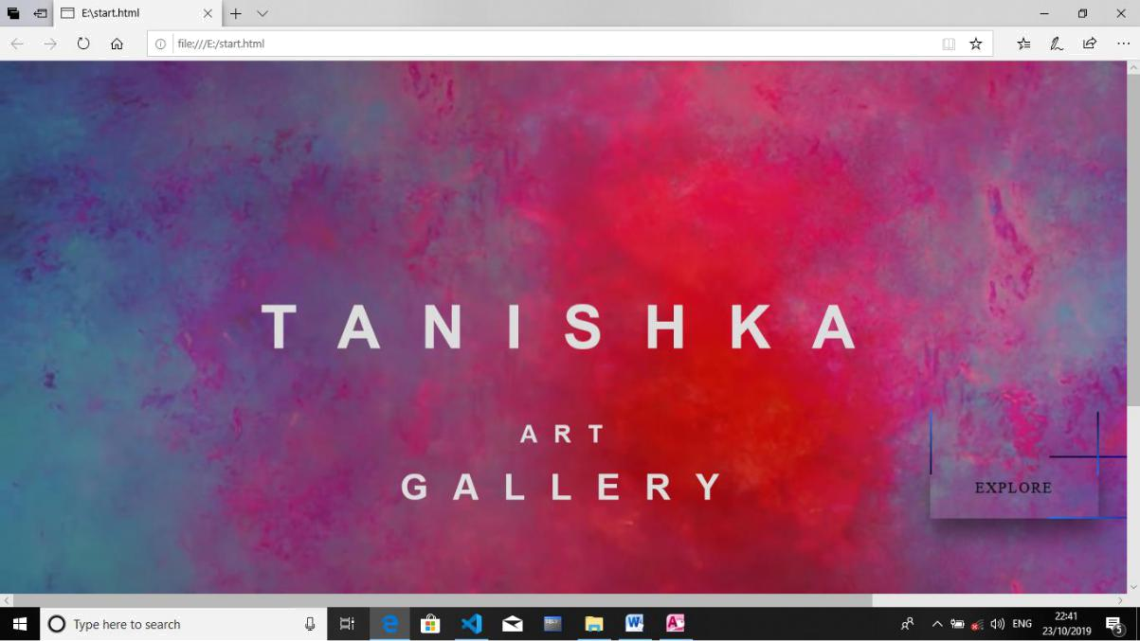

2.HOME

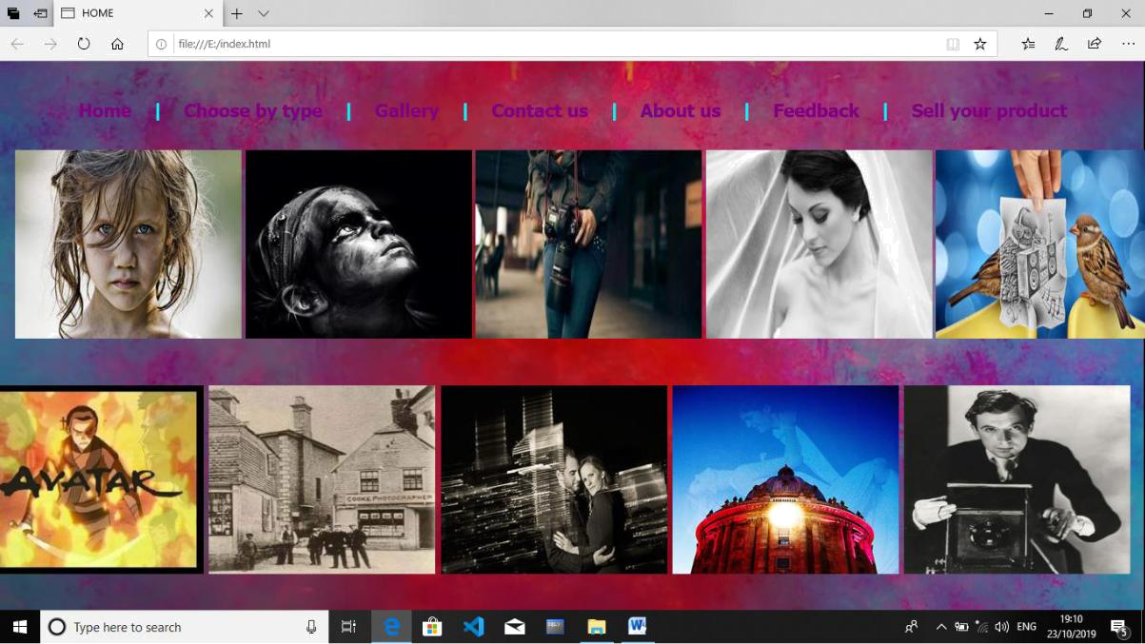

Jaysingpur College, Jaysingpur Page 23

Tanishka Art Gallery

3.CHOOSE BY TYPE:

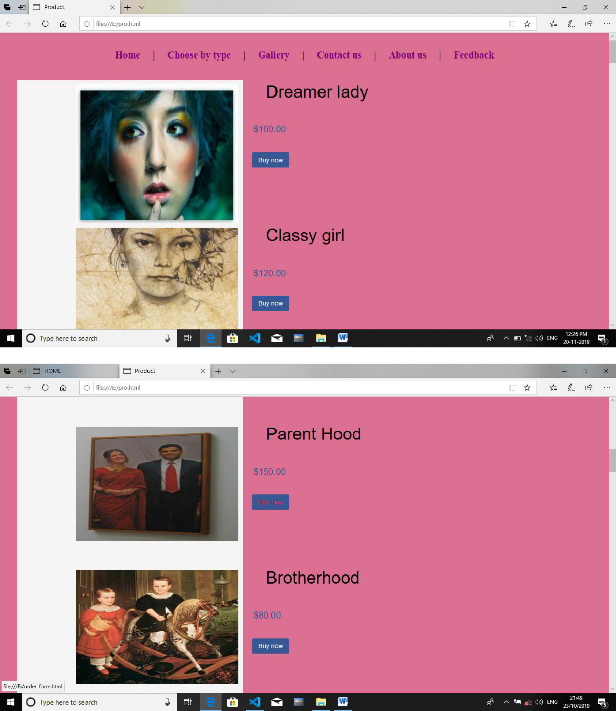

Jaysingpur College, Jaysingpur Page 24

Tanishka Art Gallery

AFTER CLICKING ON BUY NOW:

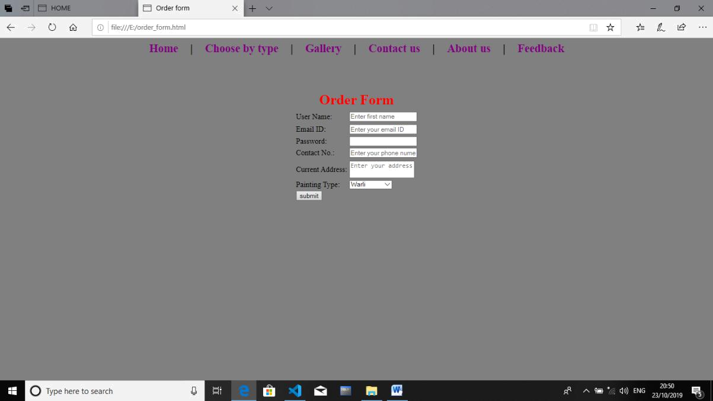

4.Gallery:
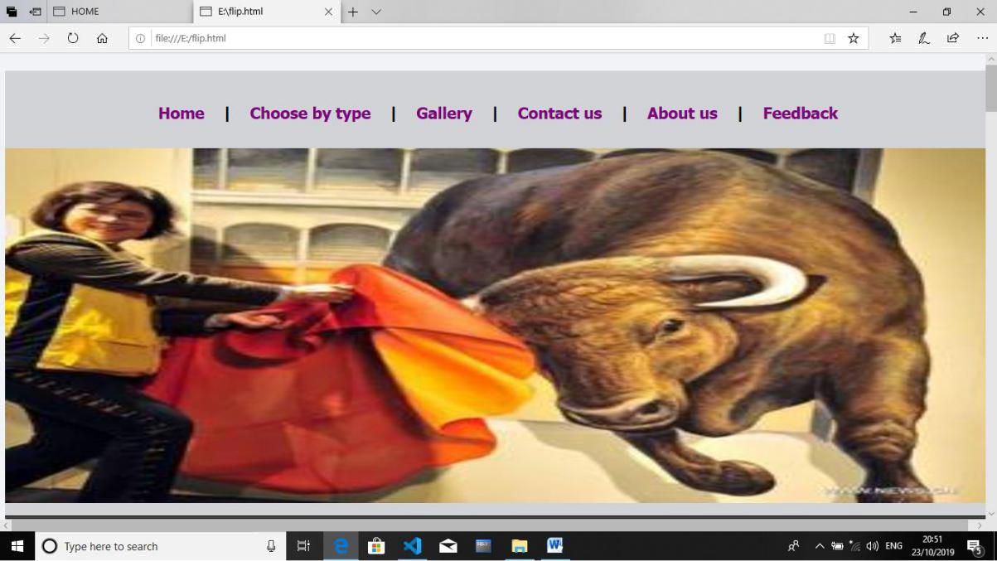

Jaysingpur College, Jaysingpur Page 25

Tanishka Art Gallery

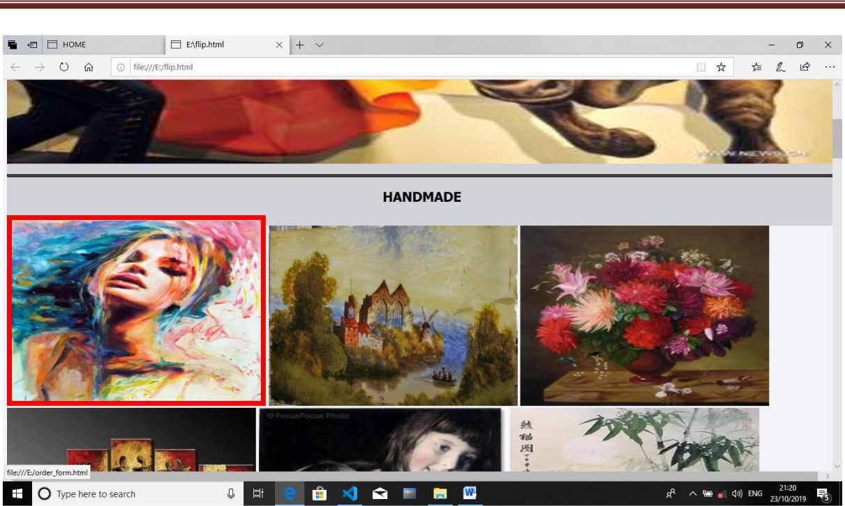

AFTER CLICKING ON IMAGE:
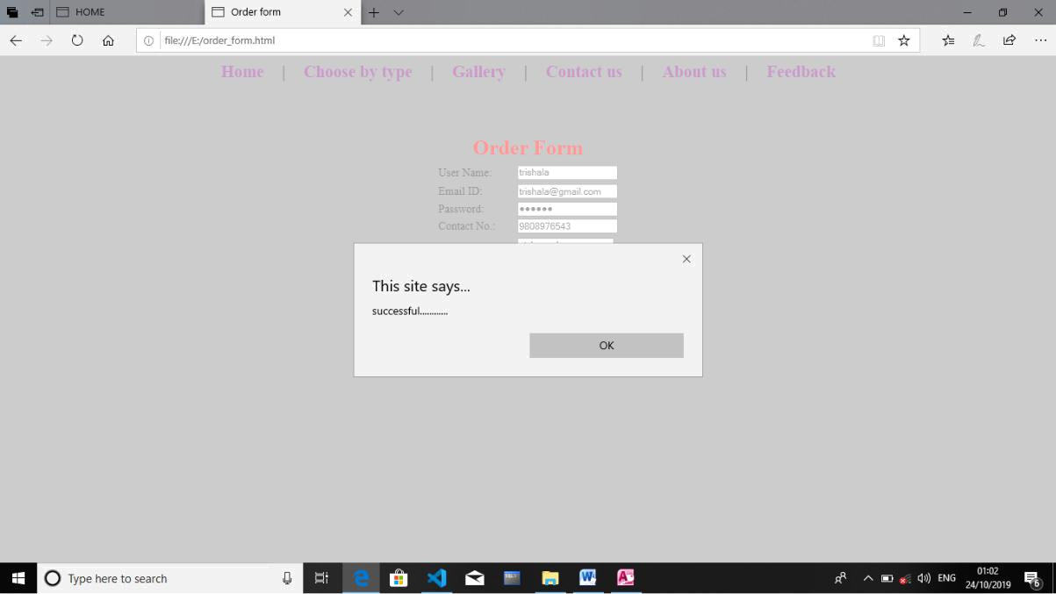

Jaysingpur College, Jaysingpur Page 26

Tanishka Art Gallery

5.CONTACT US
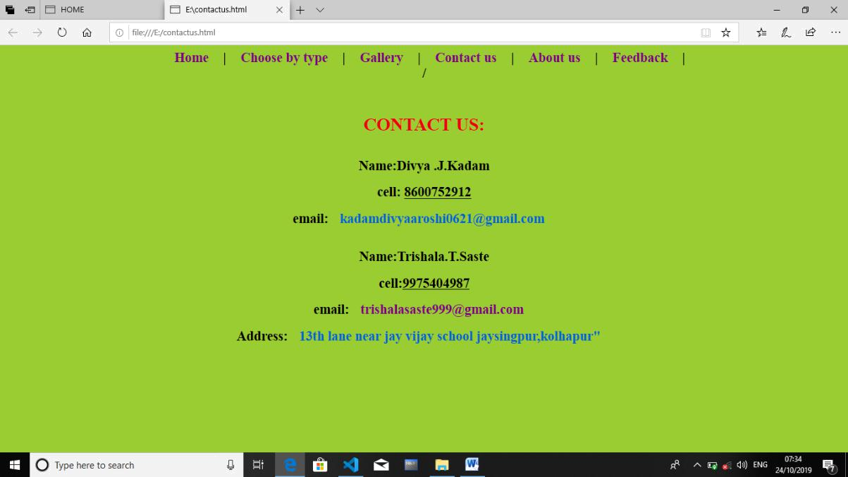

6.ABOUT US:

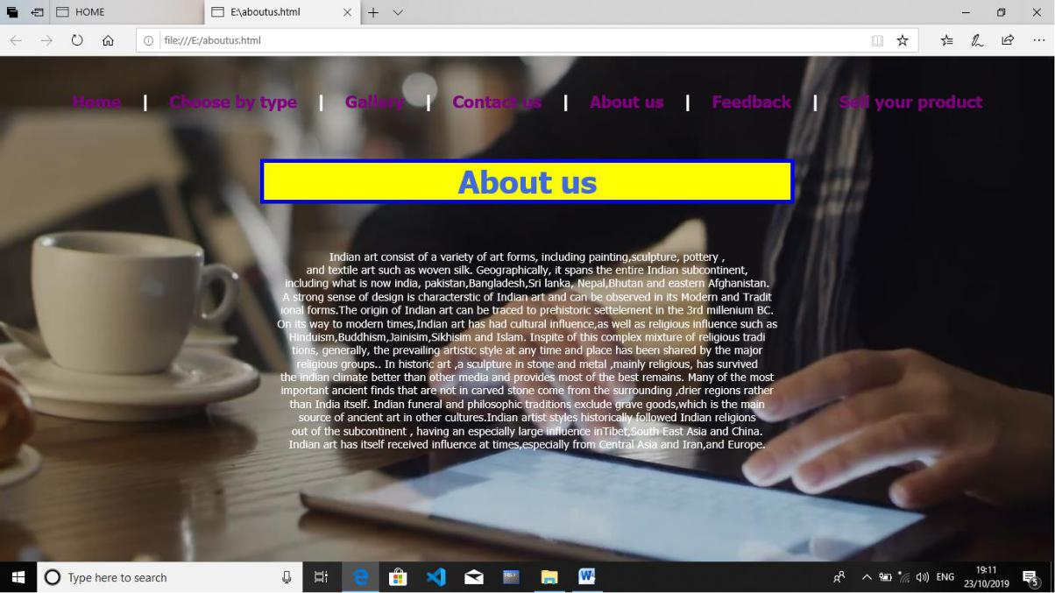

Jaysingpur College, Jaysingpur Page 27

Tanishka Art Gallery

7.FEEDBACK:

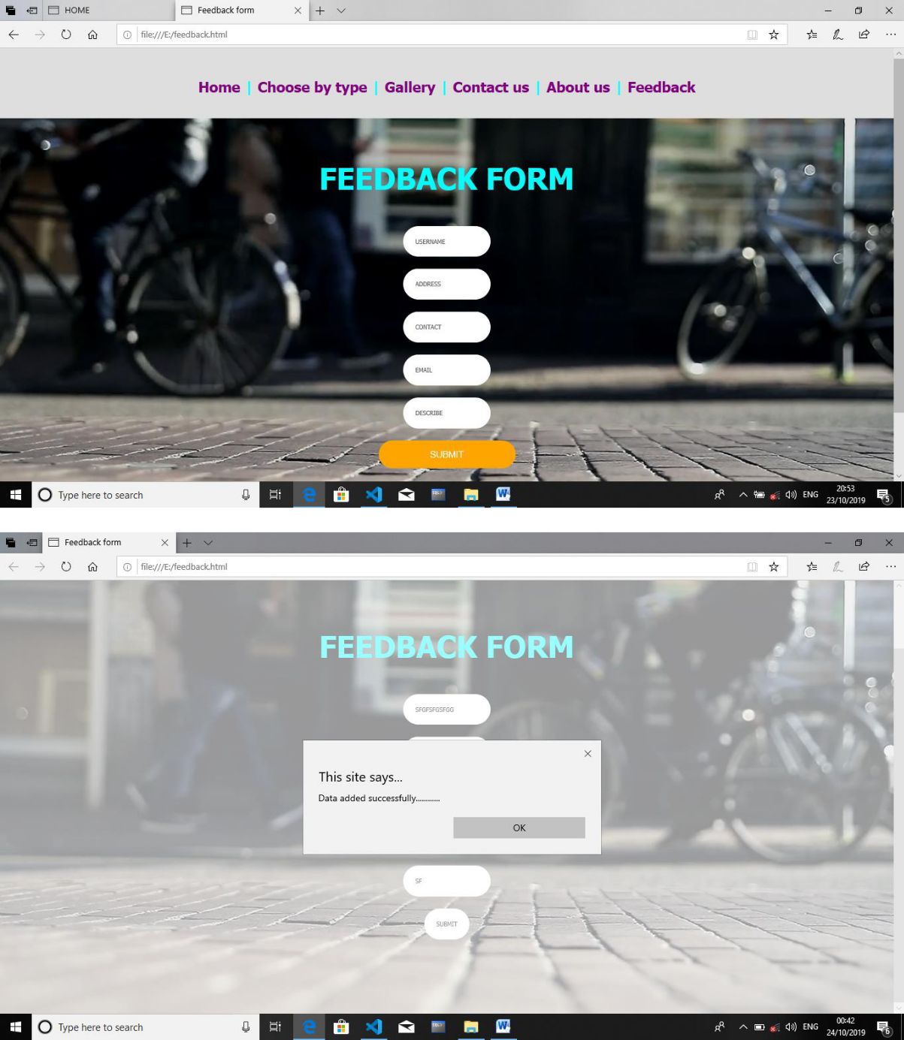

Jaysingpur College, Jaysingpur Page 28

Tanishka Art Gallery

Order Form:-

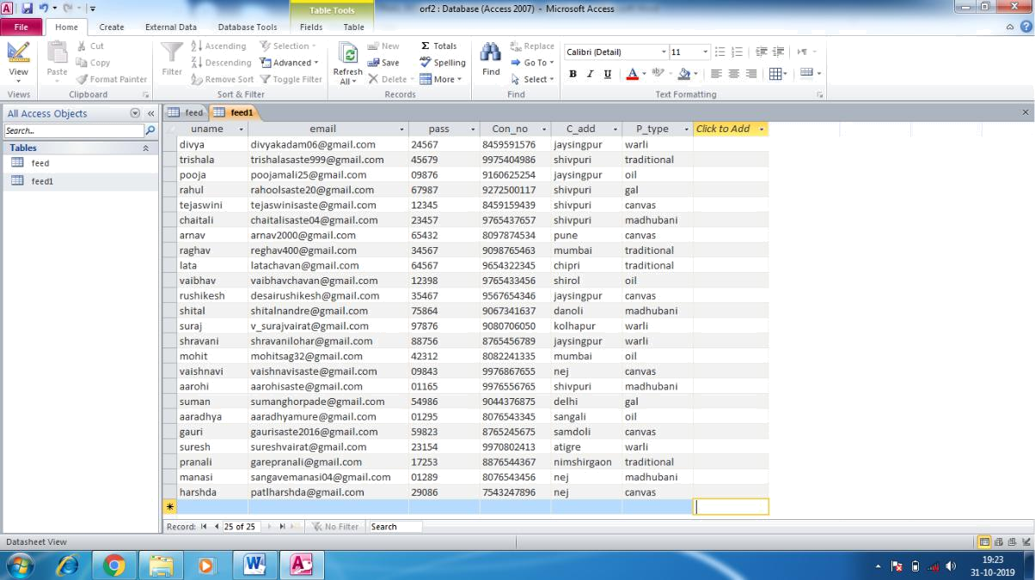

Feedback Form:-
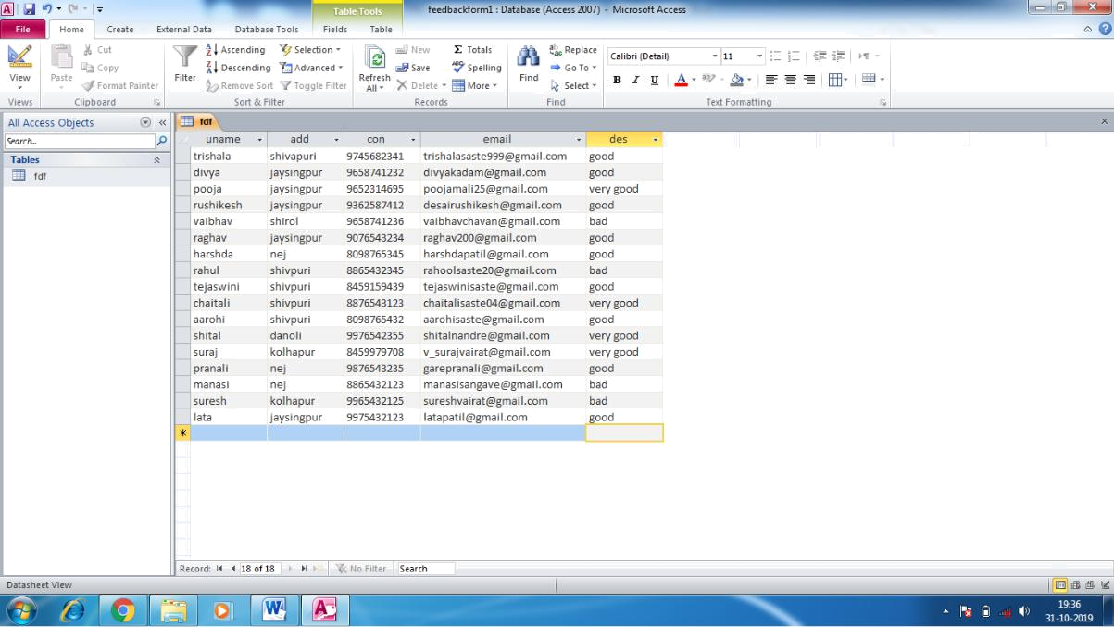

Jaysingpur College, Jaysingpur Page 29

Tanishka Art Gallery

CONCLUSION

The present computerized system “Tanishka Art Gallery” is helpful for creating up to

website through”Tanishka Art Gallery” information details. Through this information,

user can easily choose the information about .Online art gallery gives variety of arts.

User can choose best option for get knowledge. The project includes all the

information & description of the Tanishka Art Gallery.

As you can see, there are many possibilities for creating a website for yourself or someone else. No matter what your reason might be for creating a site, the objectives are essentially the same to share information and offer products, services.

The system satisfies most of its objectives like.
- It perform desired task with speed and accuracy.

- It helps in managing the data in a much better way.

- It helps in retrieving information more easily to many different users.

- It provides more information to user with in short period.

Jaysingpur College, Jaysingpur Page 30

Tanishka Art Gallery

FUTURE ENHANCEMENT

There are several important features we would like to add to this website. We have created this list to help us track improvements as well as share with the general public our goals for this project. We welcome your suggestions, and if you have a good idea, please „Contact Us‟ using our contact number, submission from and choose “Website Feedback” from the list of categories

In future is a some extra features are added like selling arts on website and new module of the feedback of this page. this will be very beneficial to the system & also for the customer. we can use attractive arts in future.

Jaysingpur College, Jaysingpur Page 31

Tanishka Art Gallery

BIBLIOGRAPHY

Reference:

- www.w3school.com

Book:

1. Analysis and dsign of information system

-James A. Senn

2. HTML4

-Rick Darnell .et.al

Jaysingpur College, Jaysingpur Page 32

